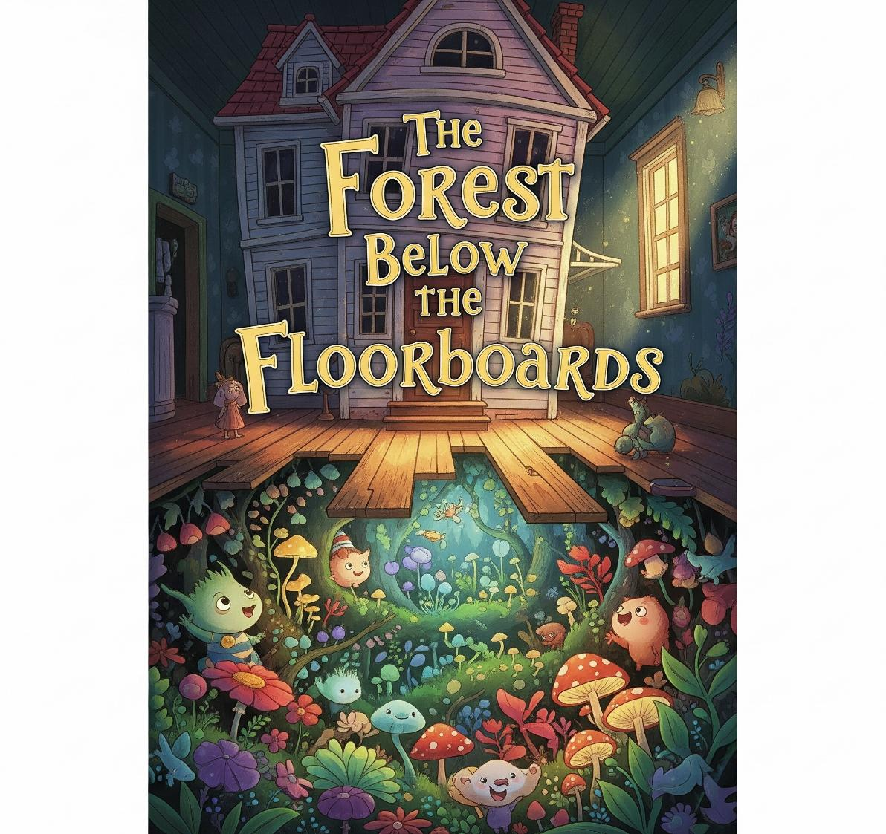

**Chapter 1: The House with No Corners**

The first thing Wren noticed was that nothing in the house was quite straight. The front door leaned a little to the right. The staircase creaked in a rhythm like footsteps behind her. Even the windows seemed to sigh when the wind passed by. Her parents had bought the house because it was “full of character.” Wren thought that was just a grown-up way of saying “weird and haunted.”

On her first night, she lay on the old iron-framed bed and listened. At first, it was the usual countryside sounds—owls, wind, the occasional dog barking. But then came something else: a *thump* from under the floorboards.

Not like pipes. Not like settling wood. It sounded... alive. The next morning, she asked her parents about it. “Probably mice,” her mom said over tea. “Or squirrels in the walls,” her dad added, sipping coffee. Neither of them looked concerned.

But Wren couldn’t stop thinking about the thump. Or how the wallpaper in her room peeled away to show shapes that looked a little too much like trees.

**Chapter 2: The Trapdoor**

Two days later, Wren found it.

She’d been playing with her cat, Miso, who darted under the living room couch and refused to come out. When she pulled the couch aside, she found a wooden square with a brass handle, a trapdoor, sunken into the floor like a secret waiting to be asked about.

She stared at it. The handle was worn, like it had been used often once, a long time ago.

“Miso?” she whispered.

A tiny paw reached up from the gap beneath the trapdoor—and pulled it open.

A gust of cool, sweet-smelling air brushed her face. Not musty or moldy like a basement. It smelled like trees. Like soil. Like forest.

She grabbed a flashlight from the hallway and opened the door all the way. A wooden ladder led down into shadows.

She hesitated.

Then she whispered, “You’re not supposed to be here,” more to herself than anything else.

But Miso was already climbing down, tail twitching.

With a sigh, Wren followed.

**Chapter 3: The Forest Beneath**

The ladder didn’t go down far maybe ten feet. But when Wren stepped off it, her foot touched moss, not cement. All around her stretched tall trees, glowing with veins of silver light. The ceiling above had vanished. Or maybe... it was the ceiling of the house, but see-through from this side.

She stood in a forest beneath her house. There were no sounds of traffic, no hum of pipes. Just birdsong, rustling leaves, and the strange rhythm of drums deep within the trees.

Miso trotted ahead like he’d done this before. Wren stumbled after him, brushing aside glowing ferns and flowers that swayed toward her like they were curious. She passed a tree with a tiny door carved into its trunk. Another tree had carvings like a language she didn’t know, but almost understood.

After a few minutes, she came upon a clearing. In the center stood a statue, an old woman made of bark and vine, with a crown of twisted roots. Moss grew over her shoulders like a shawl. Her eyes were closed, and in one hand she held a wooden staff embedded with a glowing green gem. At her feet, the ground cracked open slightly, and black vines wriggled out like fingers. Something was wrong here.

**Chapter 4: The Whisperroot Curse**

That night, Wren returned home. The trapdoor had shut itself behind her, but now she knew: the forest was real.

She went back the next day, and the next. She met a fox who spoke in riddles, a bird that sang songs from Wren’s dreams, and even a small stone golem who guarded a hollow tree library.

From the books there, she learned about the Whisperroot—a creeping darkness born from a broken oath. Long ago, her great-great-grandmother had made a promise to the forest: that her family would protect it in exchange for sheltering their dreams beneath its roots.

But over time, her family had forgotten.

The forest was dying because its guardians had stopped listening.

Now, the Whisperroot was growing, twisting its black vines through both the underground world and into the house above.

If it reached the heart of the house, it would consume both worlds.

And Wren was the only one left who could stop it.

**Chapter 5: The Final Thump**

Wren devised a plan. She gathered tokens from the forest, feathers, seeds, drops of dew, and returned to the statue.

The black vines were thicker now, pulsing. The statue’s eyes had cracked open.

“I will remember,” Wren said aloud. “I will keep the promise.”

She placed each token on the roots, speaking a word from the books: “Arvanel, peace between root and roof.”

The forest trembled.

Then... silence.

The vines recoiled, shriveled. The statue smiled faintly. The gem on the staff glowed bright, and then dimmed gently, like a heartbeat at rest.

Miso meowed.

Behind them, the ladder reappeared.

**Chapter 6: The Promise Keeper**

Wren still lives in the crooked house. But now, it feels different, less haunted, more alive.

She writes in a new journal every night, logging the forest’s changes. Sometimes she finds tiny mushrooms on her pillow, or vines curling up from under the bed in greeting.

And under the floorboards, the thumping has stopped.

Instead, there’s a quiet hum, like a lullaby sung by roots.

Wren listens.

And remembers.

***The End***